Counties of New York

New York County (Manhattan)
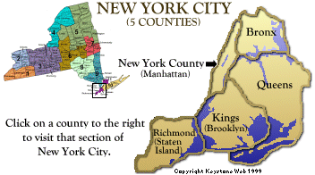

5 Burroughs of New York
Brooklyn County=Kings * Queens County=Queens * Staten Island County=Richmond
Manhattan County=New York * Bronx County=Bronx

Bronx County Clerk
851 Grand Concourse, Room B131
Bronx, NY 10451
718-618-3300
https://www.cityclerk.nyc.gov/content/

Brooklyn (Kings County)
360 Adams Street
Brooklyn, NY 11201
Ph. 347-404-9760
http://ww2.nycourts.gov/courts/2jd/kingsclerk/index.shtml

Manhattan County Clerk’s Office
60 Centre Street
New York, NY 10007
646-386-3600
https://www.cityclerk.nyc.gov/content/marriage-bureau/county-clerk

Queens
8811Sutphin Blvd #106
Jamaica, NY 11435
718-298-0600
http://ww2.nycourts.gov/COURTS/11jd/queensclerk/index.shtml

Staten Island (Richmond County)
130 Stuyvesant Place
Staten Island, NY 10301
718-675-7700
https://www.richmondcountyclerk.com/

